

**Data Brief: Opioid-related Overdose Deaths Among Massachusetts Residents**

Massachusetts Department of Public Health Posted: MAY 2016

This report contains both confirmed and estimated data through March 2016. The number of confirmed cases of unintentional opioid overdose deaths for 2015[1] (n=1379) represents an 8% increase over 20141 (n=1282), and the 2014 number (n=1282) is a 41% increase over cases for 2013 (n=911). In order to obtain timelier estimates of the total number of opioid overdose deaths in Massachusetts - confirmed and probable - the Department of Public Health (DPH) used predictive modeling techniques for all cases not yet finalized by the Office of the Chief Medical Examiner (OCME). Based on the data available as of March 31, 2016, DPH estimates that there will be an additional 63 to 85 deaths in 2014 and 118 to 179 deaths in 2015, once these cases are finalized.

Note: Counts for 2000 – 2013 are complete as of the date that the state’s statistical file was closed. Each year, a small number of cases receive a cause of death after the file is closed. We are currently reviewing these cases. The 2014 and 2015 numbers are higher than previously reported following a review of toxicology data and cause of death for previously “undetermined” cases. These cases were excluded in the last report but included in this report as confirmed opioid-related cases.

DPH has also made month-by-month estimates for all intents (unintentional/undetermined and intentional deaths) from September 2014 through March 2016. By combining data from the OCME and the Massachusetts State Police, DPH is now able to estimate opioid-related deaths much closer to real-time than was previously possible.



**Rate of Unintentional Opioid Deaths**

In 2015, the estimated rate of unintentional opioid-related overdose deaths was 22.6 deaths per 100,000 residents. This represents a 12.4% increase from the rate of 20.1 deaths per 100,000 residents in 2014.



1Unintentional poisoning/overdose deaths combine unintentional and undetermined intents to account for a change in death coding that occurred in 2005. Suicides are excluded from this analysis.

2 Opioids include heroin, opioid-based prescription painkillers, and other unspecified opioids. This report tracks opioid-related overdoses due to difficulties in identifying heroin and prescription opioids separately.

**Toxicology Analysis: Fentanyl**

Fentanyl is a synthetic opioid that has effects similar to heroin. It can be prescribed for severe pain.

The standard toxicology screen ordered by the Office of the Chief medical Examiner includes a test for the presence of fentanyl. Among the 1,319 individuals whose deaths were opioid-related in 2015 where a toxicology screen was also available, 754 of them had a positive screen result for fentanyl. While screening tests can be used to note the rate at which certain drugs are detected in toxicology reports, they are insufficient to determine the final cause of death without additional information. The cause of death is a clinical judgement made within the Office of the Chief Medical Examiner.

**Technical Notes**

The figures cited here for 2014 and 2015 are based on confirmed and estimated data. DPH regularly reviews projections as more information becomes available. Information from the OCME and the Massachusetts State Police are now incorporated into the predictive model. This additional information has improved the accuracy of the models that predict the likelihood that the cause of death for any person was an opioid-related overdose. DPH applied this model to death records for which no official cause of death was listed by the OCME. The model includes information from the death certificate, Medical Examiner’s notes, and the determination by the State Police of a suspected heroin death. DPH added this estimate to the number of confirmed cases in order to compute the total number of opioid-related overdoses. Due to missing information on intent in the open files, the models predict the total number of fatal opioid-related overdoses. In order to estimate the numbers that are considered unintentional, the Department applied the average percentage of total opioid-overdose deaths that were considered unintentional for the previous 5-year period (94%) to the total estimate. Should new information become available that changes the estimates to any significant degree, updates will be posted.



**Number of Unintentional1 Opioid2- Related Overdose Deaths by County, MA Residents: 2000-20153**

Massachusetts Department of Public Health, Office of Data Management and Outcomes Assessment Posted: MAY 2016

|  |  |  |  |  |  |  |  |  |  |  |  |  |  |  |  |  |  |  |
| --- | --- | --- | --- | --- | --- | --- | --- | --- | --- | --- | --- | --- | --- | --- | --- | --- | --- | --- |
| **County** |  | | **Year of Death** | | | | | | | | | | | | | | | |
| **2000** | **2001** | | **2002** | **2003** | **2004** | **2005** | **2006** | **2007** | **2008** | **2009** | **2010** | **2011** | **2012** | **2013** | **20143** | **20153** | **Total  2000-2015** |
| Barnstable | 12 | 17 | | 17 | 14 | 16 | 17 | 19 | 29 | 21 | 20 | 19 | 15 | 22 | 40 | 53 | 65 | 396 |
| Berkshire | 2 | 3 | | 0 | 2 | 3 | 9 | 1 | 8 | 3 | 8 | 3 | 6 | 15 | 21 | 28 | 30 | 142 |
| Bristol | 37 | 56 | | 60 | 80 | 67 | 75 | 79 | 61 | 78 | 66 | 74 | 76 | 92 | 111 | 138 | 146 | 1296 |
| Dukes | 1 | 0 | | 1 | 0 | 0 | 2 | 0 | 3 | 1 | 1 | 0 | 0 | 0 | 1 | 5 | 5 | 20 |
| Essex | 41 | 58 | | 44 | 74 | 61 | 73 | 83 | 85 | 52 | 69 | 48 | 54 | 85 | 111 | 208 | 207 | 1352 |
| Franklin | 5 | 2 | | 1 | 5 | 3 | 4 | 6 | 4 | 2 | 2 | 4 | 6 | 8 | 9 | 11 | 16 | 88 |
| Hampden | 30 | 36 | | 34 | 44 | 26 | 33 | 42 | 38 | 43 | 45 | 46 | 42 | 51 | 68 | 61 | 94 | 734 |
| Hampshire | 5 | 5 | | 4 | 10 | 8 | 2 | 9 | 12 | 10 | 9 | 10 | 9 | 10 | 28 | 25 | 17 | 173 |
| Middlesex | 56 | 76 | | 77 | 102 | 96 | 109 | 106 | 101 | 104 | 113 | 90 | 118 | 106 | 142 | 277 | 293 | 1966 |
| Nantucket | 0 | 0 | | 0 | 0 | 0 | 0 | 0 | 1 | 0 | 1 | 1 | 0 | 0 | 1 | 1 | 14 | 6 |
| Norfolk | 24 | 39 | | 34 | 36 | 37 | 49 | 46 | 53 | 67 | 64 | 55 | 59 | 65 | 79 | 124 | 144 | 976 |
| Plymouth | 22 | 24 | | 27 | 42 | 24 | 35 | 47 | 49 | 45 | 46 | 39 | 60 | 54 | 83 | 117 | 151 | 865 |
| Suffolk | 44 | 79 | | 75 | 93 | 73 | 62 | 106 | 101 | 67 | 91 | 60 | 79 | 82 | 105 | 145 | 179 | 1441 |
| Worcester | 59 | 73 | | 55 | 47 | 42 | 55 | 71 | 69 | 68 | 64 | 77 | 79 | 78 | 112 | 163 | 177 | 1289 |
| **TOTAL DEATHS** | **338** | **468** | | **429** | **549** | **456** | **525** | **615** | **614** | **561** | **599** | **526** | **603** | **668** | **911** | **1,3555** | **1,526** | **10,743** |

1Unintentional poisoning/overdose deaths combine unintentional and undetermined intents to account for a change in death coding that occurred in 2005. Suicides are excluded from this analysis.

2 Opioids include heroin, opioid-based prescription painkillers, and other unspecified opioids.

3 Please note that 2014-2015 death data are preliminary and subject to updates. Case reviews of deaths are evaluated and updated on an ongoing basis. A large number of death certificates have yet to be assigned final cause-of-death codes. These counts are based on the estimates rather than confirmed cases. Data updated on 03/31/2016.

4 Numbers and calculations based on values less than 5 are suppressed for years in which the death file is not yet closed if they are based on pending cases. The 1 death listed in Nantucket County in 2015 is a confirmed opioid overdose death.

5 In 2014, there was also 1 death of an MA resident whose city/town of residence was not known.

**Please note that there is rounding of counts for 2014-2015.**

**Technical Notes:**

1. Cases were defined using the International Classification of Disease (ICD-10) codes for mortality. The following codes were selected from the underlying cause of death field to identify poisonings/overdoses: X40-X49, Y10-Y19. All multiple cause of death fields were then used to identify an opioid-related death: T40.0, T40.1, T40.2, T40.3, T40.4, and T40.6.
2. This report tracks all opioid-related overdoses due to difficulties in reporting heroin-associated overdoses separately. Many deaths related to heroin are not specifically coded as such due to the fast metabolism of heroin into morphine.
3. To maintain consistency with NCHS reporting, the ICD-10 code F11.1 is not included, which may include opioid-related overdose death.

**Source: Registry of Vital Records and Statistics, Massachusetts Department of Public Health**

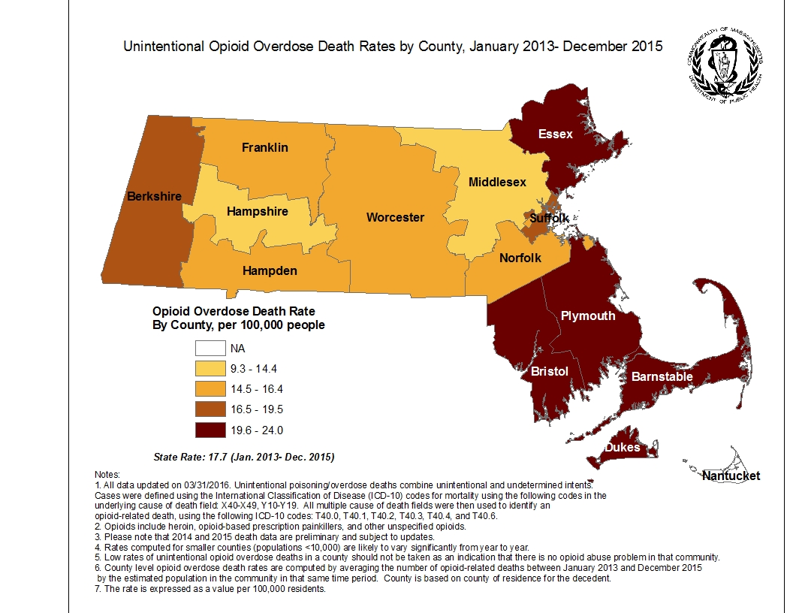



Massachusetts Department of Public Health POSTED: MAY 2016

**Number of Confirmed Unintentional/Undetermined1 Opioid-related2 Overdose Deaths by City/Town, MA Residents January 2012- December 20153**

| The table below lists the confirmed unintentional opioid overdose deaths that occurred to residents from each community in Massachusetts between 2012 and 2015. For 2014 and 2015, additional cases are still being confirmed by the Office of the Chief Medical Examiner. This report will be updated quarterly with newly confirmed cases. | | | | |
| --- | --- | --- | --- | --- |
| **City/Town** | **Year of Death** | | | |
| **2012** | **2013** | **20143** | **20153** |
| Abington | 1 | 2 | 2 | 4 |
| Acton | 2 | 0 | 3 | 3 |
| Acushnet | 2 | 0 | 0 | 3 |
| Adams | 1 | 1 | 2 | 3 |
| Agawam | 1 | 3 | 3 | 5 |
| Alford | 0 | 0 | 0 | 0 |
| Amesbury | 1 | 1 | 1 | 5 |
| Amherst | 0 | 2 | 2 | 1 |
| Andover | 1 | 4 | 4 | 4 |
| Aquinnah | 0 | 0 | 1 | 1 |
| Arlington | 4 | 3 | 5 | 7 |
| Ashburnham | 0 | 0 | 1 | 1 |
| Ashby | 0 | 0 | 0 | 0 |
| Ashfield | 0 | 0 | 0 | 1 |
| Ashland | 1 | 0 | 1 | 3 |
| Athol | 2 | 2 | 2 | 2 |
| Attleboro | 4 | 11 | 10 | 7 |
| Auburn | 0 | 2 | 1 | 1 |
| Avon | 2 | 1 | 2 | 2 |
| Ayer | 0 | 1 | 1 | 1 |
| Barnstable | 5 | 8 | 12 | 11 |
| Barre | 1 | 0 | 0 | 2 |
| Becket | 0 | 0 | 0 | 0 |
| Bedford | 2 | 0 | 2 | 0 |
| Belchertown | 1 | 3 | 2 | 2 |
| Bellingham | 3 | 1 | 2 | 2 |
| Belmont | 0 | 0 | 3 | 4 |
| Berkley | 2 | 1 | 1 | 0 |
| Berlin | 0 | 0 | 0 | 0 |
| Bernardston | 2 | 0 | 0 | 0 |
| Beverly | 7 | 4 | 8 | 11 |
| Billerica | 1 | 3 | 12 | 10 |
| Blackstone | 0 | 0 | 2 | 1 |
| Blandford | 0 | 0 | 0 | 0 |
| Bolton | 0 | 0 | 0 | 1 |
| Boston | 62 | 81 | 103 | 126 |
| Bourne | 4 | 2 | 5 | 8 |
| Boxborough | 0 | 0 | 0 | 0 |
| Boxford | 0 | 0 | 0 | 2 |
| Boylston | 0 | 0 | 0 | 1 |
| Braintree | 3 | 3 | 7 | 9 |
| Brewster | 1 | 1 | 1 | 0 |
| Bridgewater | 2 | 5 | 4 | 7 |
| Brimfield | 0 | 0 | 0 | 0 |
| Brockton | 9 | 27 | 24 | 41 |
| Brookfield | 0 | 1 | 2 | 0 |
| Brookline | 0 | 1 | 1 | 2 |
| Buckland | 0 | 1 | 0 | 1 |
| Burlington | 3 | 3 | 3 | 2 |
| Cambridge | 5 | 5 | 8 | 10 |
| Canton | 1 | 4 | 3 | 6 |
| Carlisle | 0 | 0 | 0 | 0 |
| Carver | 4 | 2 | 5 | 5 |
| Charlemont | 0 | 0 | 0 | 0 |
| Charlton | 1 | 1 | 1 | 0 |
| Chatham | 0 | 0 | 1 | 1 |
| Chelmsford | 0 | 3 | 3 | 3 |
| Chelsea | 2 | 7 | 5 | 16 |
| Cheshire | 0 | 0 | 0 | 0 |
| Chester | 0 | 0 | 0 | 0 |
| Chesterfield | 0 | 0 | 0 | 0 |
| Chicopee | 9 | 9 | 6 | 18 |
| Chilmark | 0 | 0 | 1 | 0 |
| Clarksburg | 1 | 1 | 0 | 0 |
| Clinton | 3 | 2 | 4 | 5 |
| Cohasset | 0 | 0 | 3 | 0 |
| Colrain | 0 | 0 | 0 | 0 |
| Concord | 0 | 0 | 0 | 0 |
| Conway | 0 | 0 | 0 | 0 |
| Cummington | 0 | 0 | 0 | 0 |
| Dalton | 1 | 0 | 0 | 0 |
| Danvers | 4 | 6 | 4 | 5 |
| Dartmouth | 2 | 2 | 6 | 1 |
| Dedham | 2 | 3 | 4 | 3 |
| Deerfield | 0 | 0 | 0 | 1 |
| Dennis | 2 | 3 | 7 | 2 |
| Dighton | 0 | 1 | 0 | 0 |
| Douglas | 1 | 0 | 0 | 2 |
| Dover | 0 | 0 | 0 | 0 |
| Dracut | 3 | 6 | 6 | 5 |
| Dudley | 1 | 3 | 2 | 0 |
| Dunstable | 1 | 1 | 0 | 0 |
| Duxbury | 2 | 0 | 2 | 1 |
| East Bridgewater | 0 | 4 | 2 | 1 |
| East Brookfield | 0 | 0 | 0 | 0 |
| East Longmeadow | 3 | 5 | 1 | 3 |
| Eastham | 0 | 2 | 4 | 2 |
| Easthampton | 3 | 6 | 2 | 1 |
| Easton | 1 | 2 | 7 | 5 |
| Edgartown | 0 | 0 | 0 | 0 |
| Egremont | 0 | 0 | 0 | 0 |
| Erving | 0 | 1 | 0 | 0 |
| Essex | 1 | 0 | 0 | 1 |
| Everett | 9 | 5 | 27 | 16 |
| Fairhaven | 1 | 4 | 1 | 5 |
| Fall River | 22 | 28 | 34 | 34 |
| Falmouth | 4 | 6 | 7 | 13 |
| Fitchburg | 4 | 6 | 12 | 13 |
| Florida | 0 | 0 | 0 | 0 |
| Foxborough | 0 | 1 | 3 | 0 |
| Framingham | 6 | 3 | 10 | 8 |
| Franklin | 1 | 2 | 4 | 4 |
| Freetown | 1 | 0 | 2 | 2 |
| Gardner | 1 | 4 | 4 | 6 |
| Georgetown | 0 | 1 | 2 | 2 |
| Gill | 0 | 0 | 2 | 0 |
| Gloucester | 1 | 5 | 5 | 10 |
| Goshen | 0 | 0 | 1 | 0 |
| Gosnold | 0 | 0 | 0 | 0 |
| Grafton | 0 | 3 | 2 | 1 |
| Granby | 0 | 2 | 2 | 2 |
| Granville | 0 | 0 | 0 | 0 |
| Great Barrington | 0 | 0 | 1 | 0 |
| Greenfield | 4 | 4 | 3 | 7 |
| Groton | 0 | 1 | 0 | 1 |
| Groveland | 0 | 1 | 1 | 0 |
| Hadley | 0 | 0 | 1 | 0 |
| Halifax | 1 | 4 | 0 | 1 |
| Hamilton | 0 | 1 | 1 | 0 |
| Hampden | 0 | 0 | 2 | 0 |
| Hancock | 0 | 0 | 0 | 0 |
| Hanover | 1 | 1 | 1 | 1 |
| Hanson | 1 | 1 | 0 | 6 |
| Hardwick | 0 | 0 | 0 | 2 |
| Harvard | 0 | 1 | 0 | 0 |
| Harwich | 2 | 2 | 1 | 4 |
| Hatfield | 0 | 2 | 0 | 1 |
| Haverhill | 11 | 8 | 32 | 27 |
| Hawley | 0 | 0 | 0 | 0 |
| Heath | 0 | 0 | 0 | 0 |
| Hingham | 2 | 1 | 0 | 0 |
| Hinsdale | 0 | 0 | 2 | 0 |
| Holbrook | 1 | 4 | 4 | 3 |
| Holden | 1 | 0 | 5 | 3 |
| Holland | 0 | 0 | 0 | 1 |
| Holliston | 0 | 1 | 0 | 3 |
| Holyoke | 5 | 8 | 10 | 6 |
| Hopedale | 0 | 0 | 4 | 0 |
| Hopkinton | 1 | 0 | 3 | 3 |
| Hubbardston | 0 | 0 | 1 | 2 |
| Hudson | 2 | 1 | 1 | 3 |
| Hull | 1 | 0 | 3 | 2 |
| Huntington | 0 | 0 | 0 | 0 |
| Ipswich | 3 | 1 | 4 | 3 |
| Kingston | 0 | 0 | 2 | 1 |
| Lakeville | 0 | 1 | 1 | 0 |
| Lancaster | 2 | 0 | 1 | 2 |
| Lanesborough | 0 | 0 | 0 | 1 |
| Lawrence | 6 | 9 | 24 | 23 |
| Lee | 0 | 0 | 2 | 2 |
| Leicester | 0 | 2 | 1 | 1 |
| Lenox | 0 | 1 | 0 | 0 |
| Leominster | 4 | 6 | 9 | 6 |
| Leverett | 0 | 0 | 0 | 0 |
| Lexington | 0 | 1 | 2 | 2 |
| Leyden | 0 | 0 | 0 | 0 |
| Lincoln | 0 | 0 | 0 | 0 |
| Littleton | 0 | 0 | 0 | 0 |
| Longmeadow | 1 | 2 | 0 | 0 |
| Lowell | 8 | 24 | 39 | 47 |
| Ludlow | 1 | 2 | 2 | 4 |
| Lunenburg | 1 | 2 | 2 | 2 |
| Lynn | 21 | 25 | 42 | 41 |
| Lynnfield | 0 | 0 | 1 | 2 |
| Malden | 9 | 12 | 18 | 19 |
| Manchester | 0 | 0 | 0 | 0 |
| Mansfield | 0 | 4 | 2 | 2 |
| Marblehead | 2 | 2 | 0 | 1 |
| Marion | 0 | 0 | 0 | 1 |
| Marlborough | 2 | 2 | 8 | 5 |
| Marshfield | 4 | 4 | 6 | 3 |
| Mashpee | 0 | 5 | 2 | 8 |
| Mattapoisett | 0 | 0 | 0 | 2 |
| Maynard | 2 | 0 | 2 | 3 |
| Medfield | 0 | 0 | 0 | 0 |
| Medford | 10 | 9 | 13 | 15 |
| Medway | 0 | 1 | 0 | 0 |
| Melrose | 1 | 4 | 4 | 1 |
| Mendon | 0 | 2 | 0 | 1 |
| Merrimac | 0 | 1 | 0 | 2 |
| Methuen | 0 | 6 | 11 | 5 |
| Middleborough | 4 | 5 | 5 | 10 |
| Middlefield | 1 | 0 | 0 | 0 |
| Middleton | 0 | 0 | 2 | 4 |
| Milford | 4 | 2 | 4 | 2 |
| Millbury | 1 | 2 | 4 | 3 |
| Millis | 0 | 1 | 1 | 0 |
| Millville | 0 | 0 | 0 | 0 |
| Milton | 1 | 0 | 4 | 1 |
| Monroe | 0 | 0 | 0 | 0 |
| Monson | 1 | 2 | 0 | 0 |
| Montague | 0 | 0 | 1 | 1 |
| Monterey | 0 | 0 | 0 | 0 |
| Montgomery | 0 | 0 | 0 | 0 |
| Mount Washington | 0 | 0 | 0 | 0 |
| Nahant | 0 | 0 | 0 | 1 |
| Nantucket | 0 | 1 | 1 | 1 |
| Natick | 0 | 3 | 6 | 4 |
| Needham | 0 | 0 | 0 | 1 |
| New Ashford | 0 | 0 | 0 | 1 |
| New Bedford | 25 | 27 | 27 | 46 |
| New Braintree | 0 | 0 | 0 | 0 |
| New Marlborough | 0 | 0 | 1 | 0 |
| New Salem | 0 | 0 | 0 | 1 |
| Newbury | 0 | 1 | 1 | 2 |
| Newburyport | 1 | 2 | 5 | 1 |
| Newton | 5 | 1 | 6 | 6 |
| Norfolk | 1 | 0 | 0 | 1 |
| North Adams | 4 | 1 | 5 | 5 |
| North Andover | 2 | 1 | 3 | 3 |
| North Attleboro | 5 | 5 | 6 | 6 |
| North Brookfield | 2 | 0 | 1 | 0 |
| North Reading | 0 | 1 | 2 | 1 |
| Northampton | 1 | 3 | 11 | 4 |
| Northborough | 1 | 0 | 0 | 0 |
| Northbridge | 2 | 1 | 1 | 4 |
| Northfield | 0 | 0 | 0 | 1 |
| Norton | 4 | 4 | 4 | 1 |
| Norwell | 1 | 1 | 3 | 3 |
| Norwood | 2 | 1 | 4 | 5 |
| Oak Bluffs | 0 | 1 | 1 | 2 |
| Oakham | 0 | 0 | 0 | 0 |
| Orange | 2 | 2 | 2 | 2 |
| Orleans | 0 | 1 | 0 | 0 |
| Otis | 0 | 0 | 0 | 0 |
| Oxford | 3 | 1 | 5 | 2 |
| Palmer | 2 | 1 | 1 | 2 |
| Paxton | 1 | 1 | 1 | 1 |
| Peabody | 3 | 12 | 12 | 8 |
| Pelham | 0 | 0 | 0 | 0 |
| Pembroke | 4 | 1 | 5 | 3 |
| Pepperell | 1 | 1 | 3 | 1 |
| Peru | 0 | 0 | 0 | 0 |
| Petersham | 0 | 1 | 0 | 0 |
| Phillipston | 1 | 0 | 0 | 0 |
| Pittsfield | 8 | 14 | 13 | 16 |
| Plainfield | 0 | 0 | 2 | 0 |
| Plainville | 2 | 1 | 0 | 0 |
| Plymouth | 6 | 6 | 17 | 18 |
| Plympton | 0 | 0 | 0 | 0 |
| Princeton | 1 | 1 | 1 | 1 |
| Provincetown | 0 | 0 | 1 | 0 |
| Quincy | 23 | 26 | 37 | 37 |
| Randolph | 4 | 5 | 7 | 12 |
| Raynham | 1 | 2 | 4 | 3 |
| Reading | 1 | 1 | 3 | 4 |
| Rehoboth | 0 | 0 | 0 | 1 |
| Revere | 11 | 15 | 24 | 13 |
| Richmond | 0 | 1 | 0 | 0 |
| Rochester | 0 | 0 | 0 | 0 |
| Rockland | 1 | 3 | 5 | 9 |
| Rockport | 2 | 0 | 2 | 3 |
| Rowe | 0 | 0 | 0 | 0 |
| Rowley | 1 | 2 | 0 | 0 |
| Royalston | 0 | 1 | 0 | 0 |
| Russell | 0 | 0 | 0 | 0 |
| Rutland | 1 | 0 | 2 | 0 |
| Salem | 5 | 6 | 12 | 12 |
| Salisbury | 3 | 1 | 4 | 4 |
| Sandisfield | 0 | 0 | 0 | 0 |
| Sandwich | 1 | 2 | 3 | 2 |
| Saugus | 9 | 6 | 7 | 3 |
| Savoy | 0 | 0 | 0 | 0 |
| Scituate | 1 | 1 | 5 | 3 |
| Seekonk | 0 | 0 | 1 | 0 |
| Sharon | 2 | 3 | 3 | 1 |
| Sheffield | 0 | 0 | 1 | 0 |
| Shelburne | 0 | 0 | 2 | 1 |
| Sherborn | 0 | 0 | 1 | 1 |
| Shirley | 1 | 0 | 3 | 1 |
| Shrewsbury | 0 | 6 | 1 | 2 |
| Shutesbury | 0 | 0 | 0 | 0 |
| Somerset | 2 | 1 | 2 | 3 |
| Somerville | 4 | 8 | 14 | 19 |
| South Hadley | 1 | 4 | 0 | 2 |
| Southampton | 0 | 1 | 0 | 1 |
| Southborough | 0 | 0 | 0 | 0 |
| Southbridge | 2 | 2 | 3 | 5 |
| Southwick | 1 | 0 | 2 | 1 |
| Spencer | 0 | 1 | 2 | 7 |
| Springfield | 22 | 22 | 20 | 36 |
| Sterling | 1 | 1 | 0 | 0 |
| Stockbridge | 0 | 1 | 0 | 0 |
| Stoneham | 2 | 2 | 5 | 6 |
| Stoughton | 4 | 7 | 10 | 10 |
| Stow | 0 | 0 | 0 | 1 |
| Sturbridge | 0 | 1 | 1 | 1 |
| Sudbury | 1 | 0 | 0 | 0 |
| Sunderland | 0 | 1 | 0 | 0 |
| Sutton | 0 | 0 | 0 | 0 |
| Swampscott | 0 | 3 | 3 | 1 |
| Swansea | 4 | 4 | 5 | 0 |
| Taunton | 14 | 13 | 18 | 14 |
| Templeton | 1 | 1 | 2 | 1 |
| Tewksbury | 2 | 1 | 7 | 8 |
| Tisbury | 0 | 0 | 1 | 2 |
| Tolland | 0 | 0 | 0 | 0 |
| Topsfield | 1 | 1 | 1 | 0 |
| Townsend | 1 | 4 | 2 | 1 |
| Truro | 0 | 0 | 0 | 0 |
| Tyngsborough | 2 | 1 | 1 | 5 |
| Tyringham | 0 | 0 | 0 | 1 |
| Upton | 1 | 1 | 0 | 0 |
| Uxbridge | 3 | 2 | 1 | 4 |
| Wakefield | 1 | 6 | 5 | 3 |
| Wales | 0 | 0 | 0 | 0 |
| Walpole | 1 | 2 | 1 | 3 |
| Waltham | 3 | 8 | 9 | 8 |
| Ware | 3 | 4 | 4 | 2 |
| Wareham | 2 | 9 | 8 | 8 |
| Warren | 0 | 1 | 2 | 1 |
| Warwick | 0 | 0 | 0 | 0 |
| Washington | 0 | 0 | 0 | 0 |
| Watertown | 1 | 7 | 3 | 7 |
| Wayland | 1 | 0 | 1 | 1 |
| Webster | 4 | 3 | 4 | 3 |
| Wellesley | 0 | 0 | 0 | 1 |
| Wellfleet | 0 | 1 | 1 | 0 |
| Wendell | 0 | 0 | 0 | 0 |
| Wenham | 0 | 1 | 1 | 1 |
| West Boylston | 1 | 1 | 3 | 0 |
| West Bridgewater | 3 | 2 | 4 | 0 |
| West Brookfield | 0 | 1 | 2 | 0 |
| West Newbury | 0 | 0 | 0 | 0 |
| West Springfield | 0 | 7 | 5 | 6 |
| West Stockbridge | 0 | 0 | 0 | 0 |
| West Tisbury | 0 | 0 | 1 | 0 |
| Westborough | 0 | 0 | 1 | 3 |
| Westfield | 4 | 7 | 6 | 7 |
| Westford | 0 | 0 | 2 | 0 |
| Westhampton | 0 | 0 | 0 | 0 |
| Westminster | 0 | 0 | 1 | 0 |
| Weston | 0 | 1 | 1 | 0 |
| Westport | 2 | 2 | 3 | 2 |
| Westwood | 0 | 0 | 2 | 2 |
| Weymouth | 11 | 12 | 14 | 22 |
| Whately | 0 | 0 | 0 | 0 |
| Whitman | 4 | 3 | 2 | 3 |
| Wilbraham | 1 | 0 | 1 | 1 |
| Williamsburg | 0 | 1 | 0 | 0 |
| Williamstown | 0 | 1 | 1 | 0 |
| Wilmington | 2 | 3 | 4 | 7 |
| Winchendon | 2 | 1 | 2 | 0 |
| Winchester | 0 | 0 | 4 | 1 |
| Windsor | 0 | 0 | 0 | 0 |
| Winthrop | 7 | 2 | 3 | 7 |
| Woburn | 6 | 6 | 5 | 5 |
| Worcester | 24 | 43 | 55 | 57 |
| Worthington | 0 | 0 | 0 | 0 |
| Wrentham | 1 | 0 | 1 | 2 |
| Yarmouth | 3 | 7 | 5 | 9 |
| Unknown | 0 | 0 | 1 | 0 |
| **TOTAL** | **668** | **911** | **1,282** | **1,379** |

1Unintentional poisoning/overdose deaths combine unintentional and undetermined intents to account for a change in death coding that occurred in 2005. Suicides are excluded from this analysis.

2Opioids include heroin, opioid-based prescription painkillers, and other unspecified opioids.

3Please note that 2014 and 2015 death data are preliminary and subject to updates. Case reviews of deaths are evaluated and updated on an ongoing basis. A large number of death certificates have yet to be assigned final cause-of-death codes. The information presented in this report only includes confirmed cases. Data updated on 03/31/2016.

**Technical Notes**

1. Cases were defined using the International Classification of Disease (ICD-10) codes for mortality. The following codes were selected from the underlying cause of death field to identify poisonings/overdoses: X40-X49, Y10-Y19. All multiple cause of death fields were then used to identify an opioid-related death: T40.0, T40.1, T40.2, T40.3, T40.4, and T40.6.
2. This report tracks all opioid-related overdoses due to difficulties in reporting heroin-associated overdoses separately. Many deaths related to heroin are not specifically coded as such due to the fast metabolism of heroin into morphine.
3. To maintain consistency with NCHS reporting, the ICD-10 code F11.1 is not included, which may include opioid-related overdose deaths.

**Source: Registry of Vital Records and Statistics, Massachusetts Department of Public Health**



**Data Brief: Confirmed Unintentional/Undetermined1 Opioid-related2 Overdose Deaths Among Massachusetts Residents – Demographic Data Highlights**

Massachusetts Department of Public Health Posted: MAY 2016

This data brief highlights demographic data from confirmed overdose deaths from January 2015 through December 2015.

**Confirmed Unintentional/Undetermined1 Opioid-related Deaths by Gender: 2015**

|  |  |
| --- | --- |
| **Unintentional/Undetermined Opioid Deaths by Gender: 2015** | |
| Male | **1,048** |
| Female | **331** |
| **Total** | **1,379** |

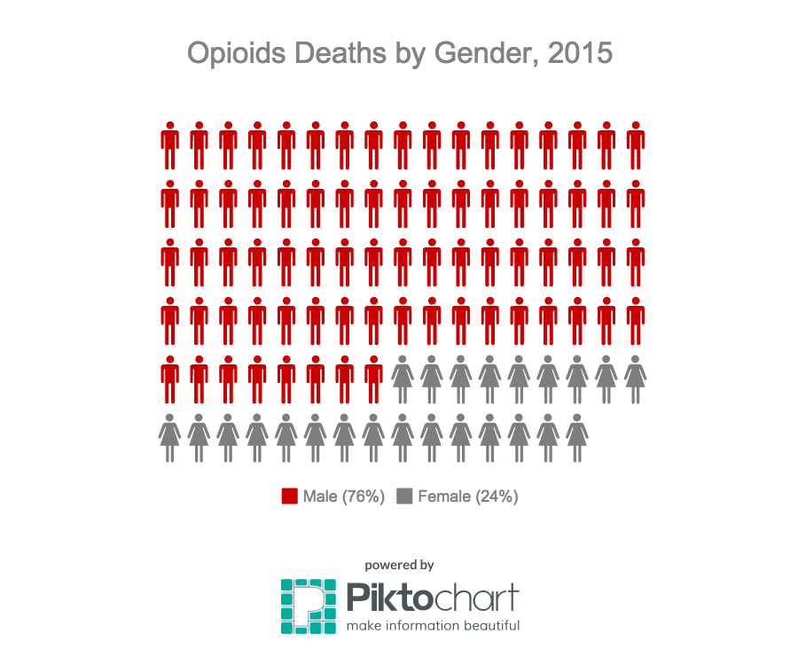

1 Unintentional poisoning/overdose deaths combine unintentional and undetermined intents to account for a change in death coding that occurred in 2005. Suicides are excluded from this analysis.

2 Opioids include heroin, opioid-based prescription painkillers, and other unspecified opioids.

**Confirmed Unintentional/Undetermined1 Opioid-related Deaths Compared to All Deaths by Age: 2015**

|  |  |  |  |  |  |  |  |  |  |
| --- | --- | --- | --- | --- | --- | --- | --- | --- | --- |
|  | **Deaths by Age: 2015** | | | | | | | | |
|  | **0-14** | **15-24** | **25-34** | **35-44** | **45-54** | **55-64** | **65+** | **Unknown** | **Total** |
| All Deaths | 393 | 481 | 1086 | 1270 | 3077 | 5995 | 44,055 | 5 | **56,362** |
| Confirmed Unintentional / Undetermined1 Opioid Deaths | 1 | 142 | 437 | 350 | 302 | 132 | 15 | 0 | **1,379** |

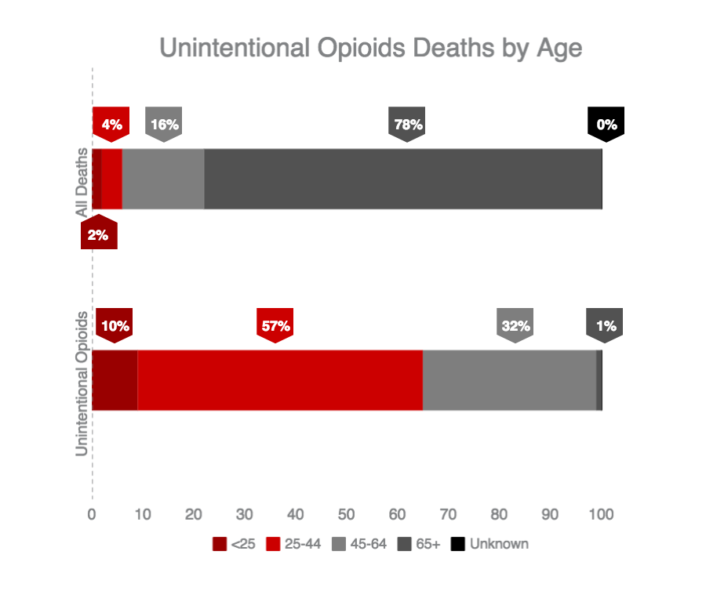

1 Unintentional poisoning/overdose deaths combine unintentional and undetermined intents to account for a change in death coding that occurred in 2005. Suicides are excluded from this analysis.

**Confirmed Unintentional/Undetermined1 Opioid-related Deaths Compared to All Deaths by Race: 2015**

|  |  |  |  |  |  |  |
| --- | --- | --- | --- | --- | --- | --- |
|  | **White non-Hispanic** | **Black non-Hispanic** | **Asian non-Hispanic** | **Hispanic** | **Other/**  **Unknown** | **Total** |
| All Deaths | 50,413 | 2,343 | 1,066 | 1,996 | 504 | **56,362** |
| Unintentional/Undetermined1 Opioid Deaths | 1,162 | 63 | 6 | 125 | 23 | **1,379** |

**Unintentional/Undetermined1 opioid-related deaths, compared to all deaths: 2015**



1 Unintentional poisoning/overdose deaths combine unintentional and undetermined intents to account for a change in death coding that occurred in 2005. Suicides are excluded from this analysis.

**Technical Notes**

2015 death data are preliminary and subject to updates. Case reviews of deaths are evaluated and updated on an ongoing basis. A large number of deaths have yet to be assigned final cause-of-death codes. The information presented in this report only includes confirmed cases. Data updated on 03/31/2016.

**Source: Registry of Vital Records and Statistics, Massachusetts Department of Public Health**



**MA Prescription Monitoring Program County-Level Data Measures (2016 Quarter 1)**

Massachusetts Department of Public Health Posted: MAY 2016

The Department of Public Health’s (DPH) Prescription Drug Monitoring Program (PMP) serves as a repository of data for all prescription drugs dispensed statewide, including those prescriptions that are sought after for illicit and non-medical use and thus represent the highest potential for abuse (federal Schedules II – V, including certain narcotics, stimulants and sedatives). The PMP also enables prescribers and dispensers to access a patient’s prescription history and can be used as a clinical decision-making tool, allowing the provider to have a holistic view of the patient’s medications.

When interpreting PMP county-level data, it is important to emphasize that increases or decreases in a single measure may not indicate an increase or decrease in prescription misuse or abuse. Put simply, use does not always equate to abuse. There are many factors that might explain an unusually high rate of prescribing in a given area. For instance, an area which contains a large number of residents in long-term care facilities may result a high rate of opioid prescribing.  
  
These datasets inform critical discussions about opioid prescribing, provide an important baseline to better inform future policy decisions and allow the state and stakeholders to more meaningfully measure whether policy initiatives are effective.  
  
Effective October 6, 2014, all hydrocodone combination drug (HCD) products (e.g., Vicodin) were reclassified from Schedule III to Schedule II. This reclassification during the last quarter of 2014 makes comparisons over time difficult to interpret. Beginning with calendar year (CY) 2015 data, reports of Schedule II products will include all HCD prescriptions.   
  
Individuals with activity of concern "thresholds" for this report are based on a 3-month time period. MDPH also releases an annual county-level report that provides thresholds that are based on a 12-month time period. Although the numbers (or rates) generated may appear to be comparable, they represent different time periods and are NOT an apples-to-apples comparison. The results are only comparable when the thresholds (e.g., 4 different providers and 4 different pharmacies), time interval (e.g. over a three-month period), and drug products analyzed (e.g. Schedule II opioids) are the same. Meaning, the total number (or rates) of individuals who received Schedule II-V opioid prescriptions from 4 or more providers and had them filled at 4 or more pharmacies in a 3-month period cannot and should not be compared with the total number of individuals (or rates) who received Schedule II-V opioid prescriptions from 4 or more providers and had them filled at 4 or more pharmacies in a 12-month period.

|  |  |  |  |  |  |  |  |
| --- | --- | --- | --- | --- | --- | --- | --- |
| County (County classifications are by patient zip code; patient state must also = MA) | Census  Population | Total Schedule II Opioid Prescriptions | Total Number of Schedule II Opioid Solid Dosage Units | Individuals Receiving Schedule II Opioid Prescription | % of Individuals Receiving Schedule II Opioid Prescription  (of total population) | Individuals with Activity of Concern | Rate of Individuals with Activity of Concern  (per 1,000) |
| Barnstable | 214,990 | 30,181 | 1,765,042 | 13,918 | 6.5 | 34 | 2.4 |
| Berkshire | 130,016 | 16,277 | 899,723 | 7,470 | 5.7 | 11 | 1.5 |
| Bristol | 552,780 | 83,463 | 5,124,401 | 37,439 | 6.8 | 50 | 1.3 |
| Dukes | 17,256 | 2,145 | 128,913 | 1,079 | 6.3 | <5 | NR |
| Essex | 762,550 | 83,226 | 4,650,689 | 40,629 | 5.3 | 55 | 1.4 |
| Franklin | 71,221 | 10,446 | 609,067 | 4,515 | 6.3 | <5 | NR |
| Hampden | 467,319 | 67,827 | 3,969,917 | 30,831 | 6.6 | 37 | 1.2 |
| Hampshire | 159,596 | 18,448 | 1,152,531 | 8,164 | 5.1 | 6 | 0.7 |
| Middlesex | 1,552,802 | 120,142 | 6,612,232 | 62,531 | 4.0 | 84 | 1.3 |
| Nantucket | 10,399 | 1,203 | 56,082 | 560 | 5.4 | <5 | NR |
| Norfolk | 681,845 | 65,740 | 3,788,473 | 32,940 | 4.8 | 46 | 1.4 |
| Plymouth | 501,915 | 64,041 | 3,863,091 | 30,611 | 6.1 | 42 | 1.4 |
| Suffolk | 755,503 | 57,275 | 3,486,339 | 28,860 | 3.8 | 44 | 1.5 |
| Worcester | 809,106 | 96,719 | 6,242,971 | 45,141 | 5.6 | 68 | 1.5 |
| MA | **6,687,298** | **717,133** | **42,349,471** | **344,688** | **5.2** | **484** | **1.4** |
| Note 1: Individuals with activity of concern "thresholds" for this report are based ONLY on a 3-month time period; see notes on previous page; CY16-Q1 | | | | | | | |
| Note 2: Counts greater than 0 but less than or equal to 5 are not reported. Rates based on these small values also are not reported (NR).  Note 3: Rates of individuals with activity of concern are based on the population of individuals who have received one or more Schedule II opioid prescriptions during the specified time period.  Note 4: PMP data are preliminary and subject to updates. The MA PMP database is continuously updated to allow for prescription record correction data submitted by pharmacies. This data were extracted on 04/08/2016; Release Date: April 2016.  Note 5: National Center for Health Statistics. Postcensal estimates of the resident population of the United States for July 1, 2010-July 1, 2013, by year, county, age, bridged race, Hispanic origin, and sex (Vintage 2013). | | | | | | | |



**Opioid-relatedEMS Transports**

**Massachusetts Residents: 2013-2015**

Massachusetts Department of Public Health Posted: MAY 2016

**Enhancement of Opioid Overdose Surveillance**

The Massachusetts Ambulance Trip Reporting Information System (MATRIS) is a statewide database for collecting emergency medical service (EMS) data from licensed ambulance services.  It was not specifically designed to track opioid overdose incidents. The Department of Public Health (DPH) is currently working with all EMS providers to improve the quality and completeness of these data especially with respect to opioid overdose incidents. To more accurately identify ambulance trips that are opioid-related, several pieces of information from MATRIS are combined such as notation that a trip was listed as a poisoning, that there was an administration of naloxone, or that the patient admitted to drug use. In combination, this information allows DPH to more accurately count opioid overdose incidents.

**Results**

The trends observed between 2013 and 2015 in data obtained from MATRIS closely match the trends observed from opioid death data. The number of suspected opioid-related ambulance transports recorded in MATRIS has increased markedly since 2013 as have naloxone administrations. The table below provides specific statistics about suspected opioid-related ambulance trips and naloxone administrations, but it should be used with caution. Given the effort to improve the completeness of MATRIS data, the data below should be used in context with other information, such as opioid-related overdose death data. Recent changes may be a reflection of an increase in opioid-related EMS trips or simply improvements in reporting by EMS providers. Since these results closely align with data reported on deaths, it seems likely that some increase in opioid-related ambulance trips occurred between 2013 and the present.

**Suspected Opioid-Related Ambulance Service Transport and Naloxone Administration Statistics**

|  |  |  |  |  |  |  |  |  |
| --- | --- | --- | --- | --- | --- | --- | --- | --- |
| **All Suspected Opioid Related Incidents: 2013** | | | | | | | | |
|  | **11-14** | **15-24** | **25-34** | **35-44** | **45-54** | **55-64** | **65+** | **Total** |
| Male | --- | 654 | 1347 | 711 | 643 | 386 | 221 | 3968 |
| Female | --- | 398 | 654 | 411 | 379 | 237 | 261 | 2347 |
| Total | 13 | 1052 | 2001 | 1122 | 1022 | 623 | 482 | 6315 |

|  |  |  |  |  |  |  |  |  |
| --- | --- | --- | --- | --- | --- | --- | --- | --- |
| **All Suspected Opioid Related Incidents: 2014** | | | | | | | | |
|  | **11-14** | **15-24** | **25-34** | **35-44** | **45-54** | **55-64** | **65+** | **Total** |
| Male | --- | 1089 | 2432 | 1156 | 939 | 482 | 290 | 6389 |
| Female | --- | 596 | 1023 | 582 | 499 | 256 | 246 | 3205 |
| Total | --- | 1685 | 3455 | 1738 | 1438 | 738 | 536 | 9594 |

|  |  |  |  |  |  |  |  |  |
| --- | --- | --- | --- | --- | --- | --- | --- | --- |
| **All Suspected Opioid Related Incidents: 2015** | | | | | | | | |
|  | **0-14** | **15-24** | **25-34** | **35-44** | **45-54** | **55-64** | **65+** | **Total** |
| Male | --- | 1163 | 3080 | 1643 | 1189 | 586 | 321 | 7986 |
| Female | --- | 605 | 1369 | 730 | 581 | 336 | 272 | 3898 |
| Total | 9 | 1768 | 4449 | 2373 | 1770 | 922 | 593 | 11884 |

Note: Cells with 1-7 opioid-related incidents are suppressed

|  |  |  |  |
| --- | --- | --- | --- |
|  | **Incidents where Naloxone was Administered** | **Incidents where Naloxone was Administered More than Once** | **Total Number of Naloxone Administrations** |
| 2013 | 5443 | 1260 | 7002 |
| 2014 | 8015 | 2160 | 10720 |
| 2015 | 9127 | 2976 | 12982 |

**Technical Notes**

Suspected opioid related incidents are identified using an algorithm that DPH developed with CDC using multiple fields in the MATRIS system. Due to difference in reporting by EMS services, these numbers are likely an undercount of true opioid-related incidents.

1. Note: The 2014 and 2015 numbers are higher than previously reported following a review of toxicology data and cause of death for previously “undetermined” cases.